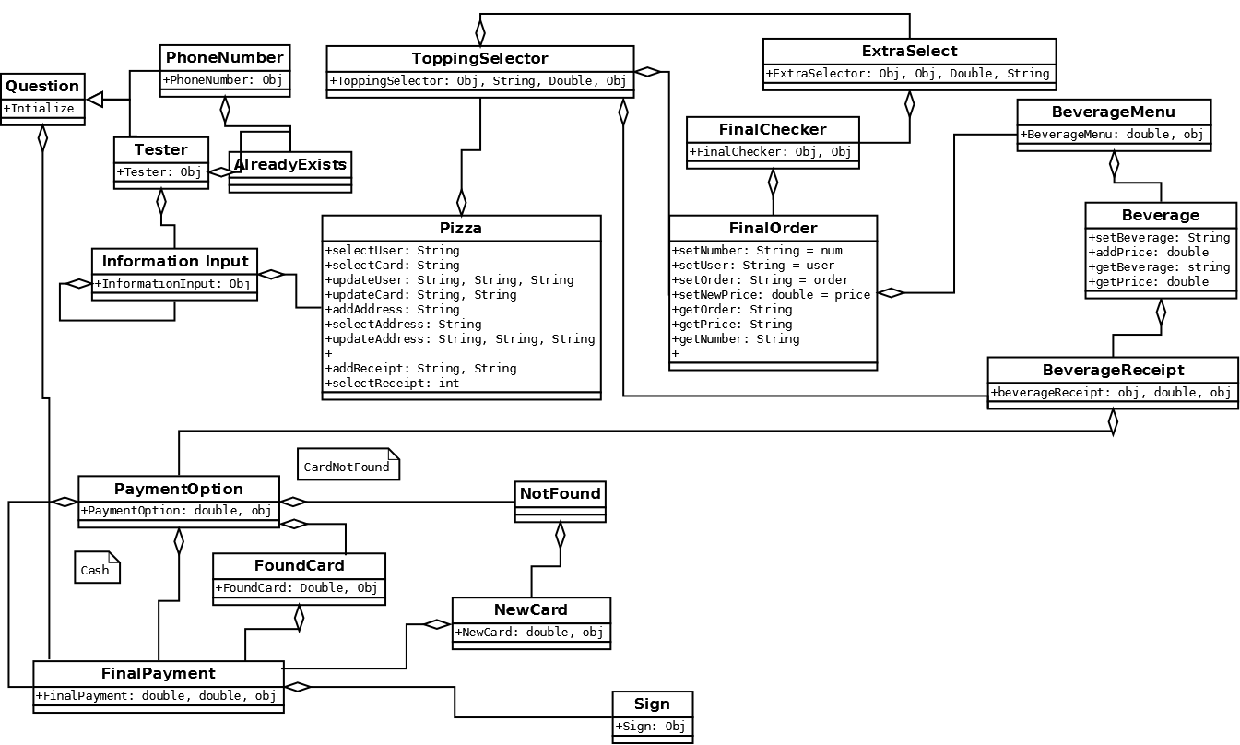

The class diagram above shows the relationship between the various class files and how they are implemented into the program, the arrows show the various relationships between the classes in the program. The relationship between the information given by the user begins with the question of if they are a new customer or not, depending upon the users input they are ultimately lead through the various classes of the application until they reach the final payment with Cash, or the Sign class when using a credit card.